PERUP SURVIVORS PERTH TOUR 2010

REPORT

In this International Year of Biodiversity, what is going on in our region?

And so we come to the culmination of a years thinking and exploring around this question. In 2009 with our Blackwood Catchment Tourists project we discovered that art can be a powerful way to sensitize to the environment and its issues. And now in 2010 we have grown our respect for art to realize that art can also be utilized to share sustainability findings with an audience. We have infact confirmed through experience the words of Picasso that, art is a lie that helps us see the truth.
Our rich research process like a spiral or labyrinth has been a journey from the outskirts toward deeper understanding and here are the sign posts that got us onto this bus to Perth. Meeting elders…designing campaigns…growing food…yoga…a bush garden…consumption and stuff…applying for project funding…Warrup debate…P.S. dancing out the debate issues… meeting the Goddesses…Perup fieldtrip…slowing down…seeing the land through fresh eyes…trapping/releasing the marsupials… finding totems…walking the land with an aboriginal guide…the little people…ecology…emotional work…the beat….the Council of Beings…puppet making…puppet moving….Warrup and fire.

Rich Process = Rich Product

Kulimba
It’s Monday morning, the 25th of October and every student and puppet and prop is on the bus and ready to go…except one kulimba. A kulimba is a South American instrument…rather odd…metal nails on a coconut base… played with ones thumbs. And the kulimba`s player thinks her kulimba is locked in a house that she has no key to enter.
10 minutes later the kulimba is once more on the bus…but that is another story.

Spare Parts
By 12.30 pm we are in Fremantle and the kids have some free time to walk off the 3 hour bus ride and get some lunch. At 2.00pm we are inside Spare Parts Puppet Theatre with Artistic Director Michael Barlow for a grueling 3 hour puppetry workshop. I don’t think education could possibly be more useful. We are just 22 hours away from our first performance at Christ Church Grammar School and still largely beginners at puppeteering. Full credit to Michael for he won everyone over with some games, (What are you doing?), taught us a simple effective puppetry warm up and vocal warm up, then tidied up all the puppetry and mask scenes in the bio-drama. The kids are treated like professionals and work solidly, quickly picking up the subtleties of the trade.

Reflects Amber (Alias Bambi and motorbike rider in the bio-drama),”Weird noises are funny”. Amber would go on to improvise outside of the script tossing performers and audience into laughter with her now legendary declaration…”ARHHH”.

Eat in or eat out?
I don’t recall which students cooked that first night, but I know all the meals were cooked by the kids, and they were delicious, and the Hostel manager was shocked that we were actually cooking for ourselves. Apparently most schools arrive and send out for pizza. This is such a shame as cooking was a highlight of our trip. One day we enjoyed chicken fettuccini made by our kids and packed into recycled containers and eaten on the grass at the Zoo. Great food at half the price with healthy ingredients. A few students fought for pre-packaged pizza bases or bottle pasta sauce. But this was our week of learning to eat and live sustainably.

Tuesday night dinner roster; Nel and Katrina…Potato bake

Given a choice most people will probably make the wrong choice
No choice… we all got up at 6.30 am and we all walked to the Mundaring Dam wall.
And the next morning we did the same but we did yoga and greeted the day.

No student records seem to exist for these early morning events.

That’s not a school, it’s a city
Upon arriving at Christ Church Grammar, our kids were a little confused by the university scale campus, year 12 student leavers and a queue of boys lining up to carry our props and puppets to the performance space. Our year 8 boys’ audience was very polite, participated in all the right places and even thanked the cast with water bottles (very environmentally unfriendly) and refreshments. A lucky start to the tour.
Reflects Katrina (Alias Kat and Honey Possum Totem and Tamar Wallaby in the bio-drama), “Perth kids are ready to take the information that we gave them

And we were away, day in day out, we visited new schools, performed. And it was different every time.

Reflects Kayla (Alias Cookie Monster and Goddess of Creation in the bio-drama),” Not everyone is nice about learning”
And Kira (Numbat and Leuwins rail and kulimba player in bio-drama),”Some people don’t help the environment because they don’t really know how. Our play helps them to understand”
And Daniel (Alias jumbo shrimp and Emu in the bio-drama),”City kids are bogans”
And Giorga ( Alias Olly and Little people and earth cycle in bio-drama ),”Christ Church guys are hot”

Afternoons were spent at Kings Park surveying art in the environment, sharing stories (Freya was first aid hug monitor) , at the Zoo seeing some of our totems up close and in the city blending in to do undercover research on urban consumption patterns.

So what did our students share with the Perth kids?
Jess...I taught them the labyrinth and what it meant.
Max…Numbats are critically endangered
Paige…Quenda is endangered and if we don’t look after the environment the quenda could die.
Dan…The country is really different and awesome
Kat…Honey possums offer special qualities to the web of life

And what did our students learn from their Perth experience?
Max…That not everyone is ready to take in the information we shared…
Nel…That it’s fun to perform in front of little kids
Paige...I leant that in this world you can teach anyone about the environment, but only the people who are ready to change listen

A final word from one of the students?
Max (Alias Pepsi sixx and Goddess of Destruction in bio-drama),” I think this trip was life changing, not just for us but for those who saw our performance and understood what we meant. It was a great experience and I don’t think any of us will ever forget it.”

So what is going on in our region?
Why does one species go extinct on this planet every 20 minutes?
Why do we cut down our Jarrah forest for Norway’s floor boards?
Why was a 1 million dollar fence just erected to protect the endangered marsupials at Perup?
And why have Bilbies, ( extinct in this region since the 1950`s), just been reintroduced at Perup?
And why are Woylies being removed from Perup on the eve of their extinction to spread their gene pool?
And why would a Department of Conservation official say that the wheat belt is moving south?
Why is the south west classified as an environment hotspot?
How can we have only 3% of our wetlands left in the south west?
What does it mean if we destroy all that is wild and natural?
What might the Perup Survivors teach us?

If some of these questions spark concern or interest in you, then you might just have a journey about to begin.

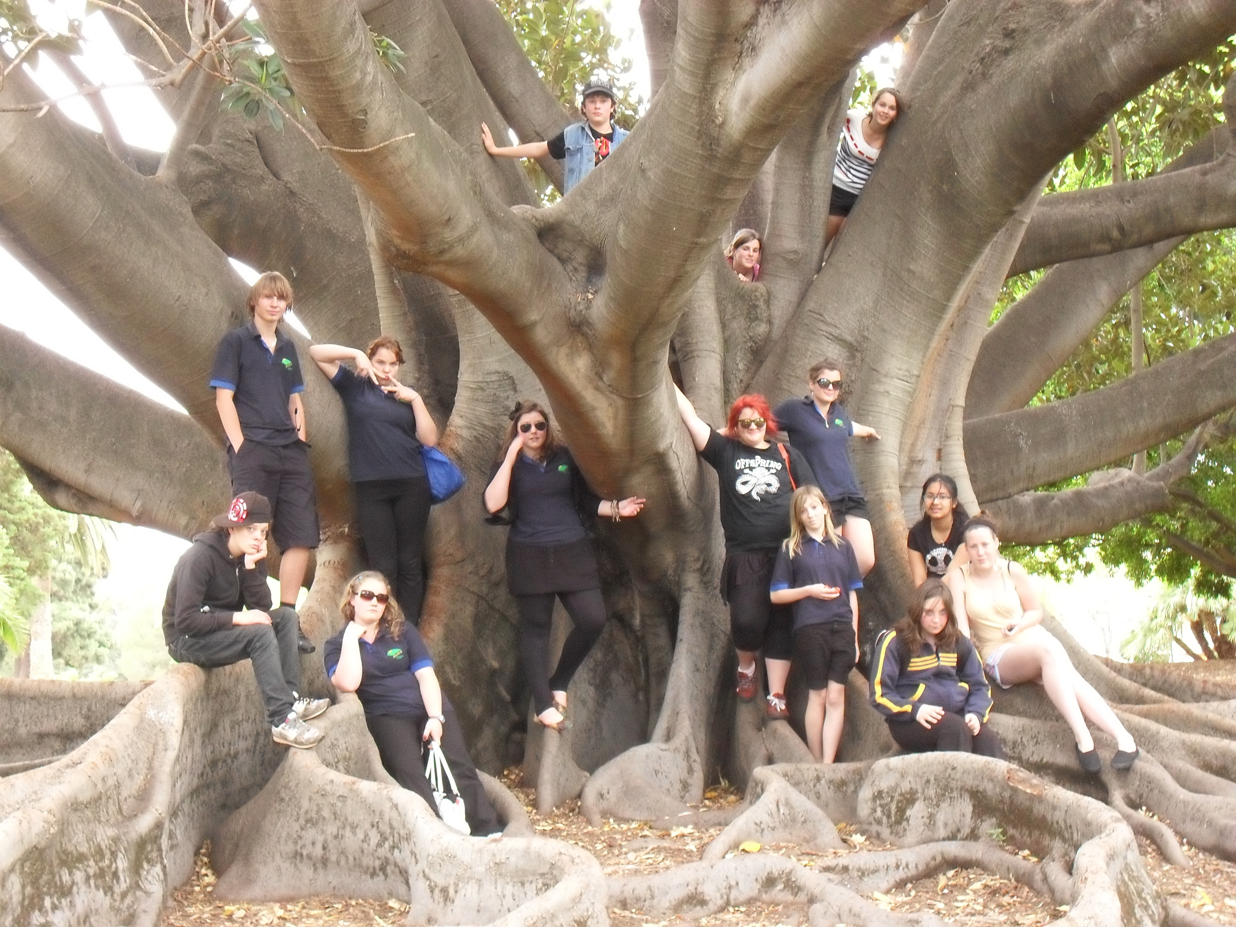

Tread lightly
Stuart Ashbil
Sustainability Coordinator
Bridgetown High School.

The above project has been made possible by the generous support of Hotrocks.

